**American International University Bangladesh (AIUB)**



**Faculty of science & Technology**

**Department of Computer Science**

**LAB MANUAL DFS**  
CSC 2211 Algorithms

|  |
| --- |
| **TITLE** |

**DFS Algorithm**

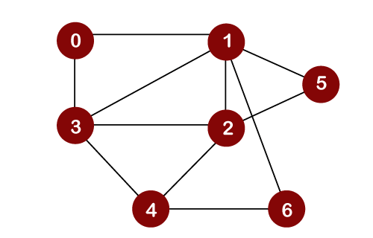

Input Graph as a adjacency List

/*

7 11

0 1

0 3

1 3

2 3

4 3

1 2

4 2

4 6

1 6

2 5

1 5

*/